**Magellan iHub / BDA / Notebook demo script**

Transcribed and combined from original script -- 7/31/2017 (cwong)

URLs changed for TestDrive demo environment – 10/3/2018 (dmelcher)

***[OPEN apps / Main Stage Demo]***

***http://*** ***td-magellan.eastus.cloudapp.azure.com/iportal***

*then navigate to the Applications folder and launch the Dryv application*

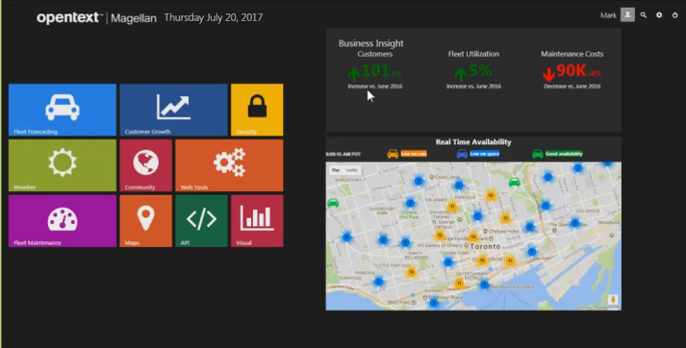

I wanted to illustrate this notion what **<insert AE name here>** was talking about… This democratization of AI, utilizing the various components that make up Magellan to enable a community of users to leverage machine learning, and the custom algorithms that have been created by our data scientists.

So for this, I’m going to assume the role of a marketing analyst at a company called Dryv (“drive”). They are a car sharing company, global organization with operations in all major cities, who standardized on OpenText technologies like **<insert what OpenText products your customers has, or mention OT products like Experience Suite, etc… as possible data sources>.**

In this example, we have Exstream from Experience Suite, xECM for Salesforce.com, and partner technology from Covisint; they all feed the data ecosystem. We use Magellan to gain a competitive edge by analyzing this information stored in these solutions. It really helps the business dominate the industry.

So as the marketing analyst, I’ll start by showing how Magellan helps our marketing dept with AI-enhanced CAMPAIGN OPTIMIZATION.

***[CLICK on Customer Growth icon] – brings up Dashboard (1 tab)***



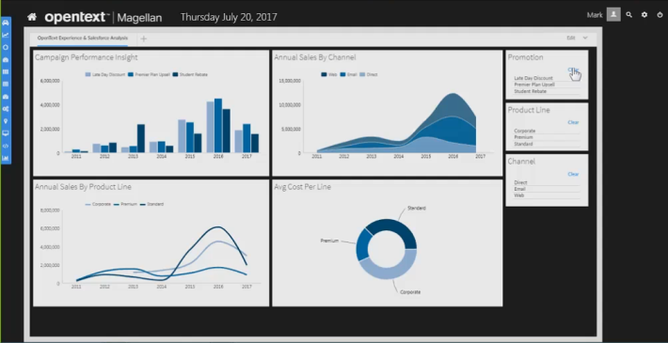

As the analyst, I’ve created this operational dashboard on our corporate portal for the field marketers. It allows them to help them identify target demographics and micro-segments for our various campaigns, and see past campaign performance.

***[CLICK on any filters to show the charts segment data]***

But as you can see, this dashboard only shows historic performance – a rear view mirror perspective. What we really need is to predict future customer behavior, and that requires sophisticated machine learning and data science. It’s not something that our field marketers are going to perform.

So thankfully, we have Magellan. It provides a simple drag-n-drop affair to leverage AI for analyzing big data like my customer data.

I’m going to switch over, and…

***[OPEN BDA – have it open in a different tab]***

[***http://td-magellan.eastus.cloudapp.azure.com/bafrontend***](http://td-magellan.eastus.cloudapp.azure.com/bafrontend)

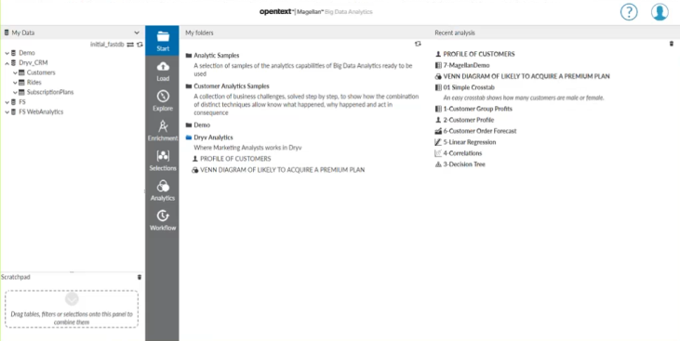

I’ll use the Data Discovery feature of Magellan, and I can harness AI that has been prepared by our data scientist. I can do it in a very simple drag and drop fashion. And I don’t require any data science skill, of course.

***[EXPAND Data tree > DryV_CRM > Customers]***

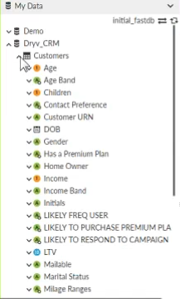

So the data in this case is covering customer history, attributes, and campaign responses that you see here. As I scroll down, you can see some interesting fields available for me.

***[Enlarge Data frame wider to show the field names LIKELY…]***

*<From original script: The data covers customer history, attributes, and campaign responses, and comes from ExStream in Experience Suite, merged with data from SFDC, giving us the context necessary for predicting likely response rates.>*

Our data scientist has prepared an algorithm. As you all know, we want to start trying to get our customers understanding algorithms. So this is a **Gaussian Naive Bayes** algorithm. It’s a clustering algorithm that will determine the propensity for one thing or another to happen.

So given the model, or algorithm by our data scientist, and I applied to our customer data, all by myself. What resulted is the depiction of customer behavior.

***[Expand “LIKELY FREQ USER” column]***

So here we have those customers most likely to be a frequent user, based on the Bayes algorithm.

***[Expand “LIKELY TO PURCHASE PREMIUM PLAN” column]  
[Hover over Y or N to show % and #s]***

We also have those most customers most likely to purchase our premium plan.

***[Expand “LIKELY TO RESPOND TO CAMPAIGN” column]***

And those customers most likely to respond to a campaign.

What I would like to do is to create a depiction of the intersection of these three (types of customers). That will give us the most fine tuned micro-segment that we should focus in on.

***[Click on Analytics > Venn]***

So I’ll utilize a simple visual in our data discovery tool for Magellan. Where we can depict, and see instantly the intersection of these three target demographics. There we get our sweet spot.

***[Drag all 3 segments of “Y” to Venn Segments]***

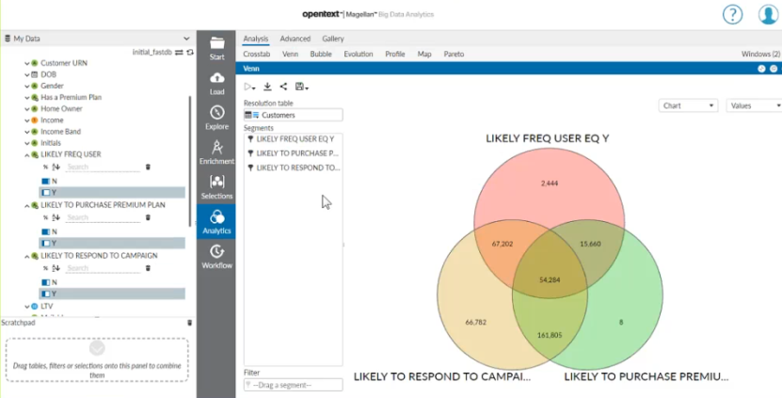

***[Move mouse over the intersection / middle of Venn – “54,284”]***

These are the customers most likely to respond to our premier plan upsell campaign.

So the visuals within the interface are also interactive. Anytime we want to segment any part of the visuals, just click it.

***[Click on the intersection / middle of Venn – “54,284”] --*** *Venn 7 appears in the scratchpad.*

What we get is a reusable drag and drop segment of data. So we can use this segment to learn about these individuals.

So let’s understand their DNA, if you will… I’ll go into Profile.

***[Switch to / Open Profile – PROFILE OF CUSTOMERS]  
(Have this preloaded to switch over, or navigate to My Folders > Dryv Analytics > PROFILE OF CUSTOMERS)***

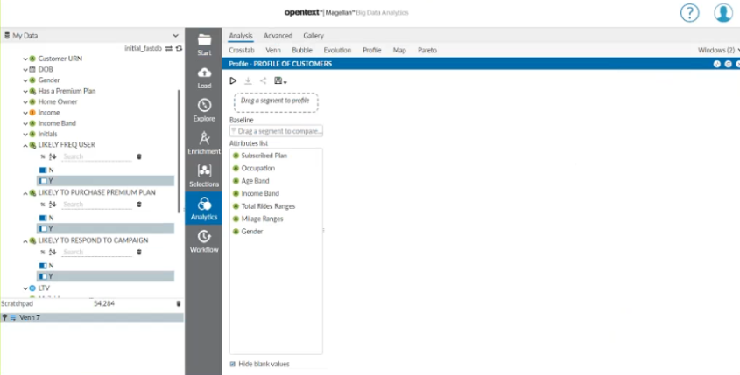

***[Drag “Venn 7” segment from Scratchpad to ‘Segment Filter’ of Profile]***

The Profile leverages the Z-Score which what I’m doing is extending that machine learning by applying another algorithm against it. In this case, the Z-Score will give me insight into those customers who are most statistically likely respond to our outreach campaign.

When we have this, we can start to see this is very conducive for **smarter** marketing.

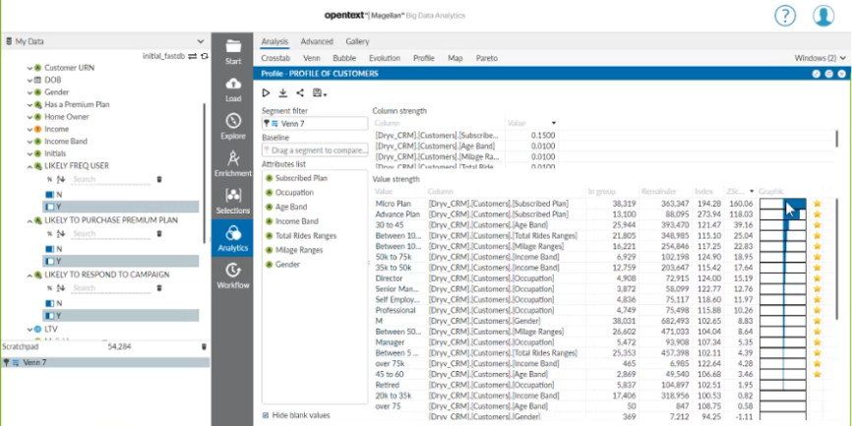

***[Move mouse over (highest) Z-Score to show what it indicates.]  
 Move over Values as you explain below. Expand column width to show the cutoff field values.***

Everything pointed out from the center to the right is indicative is a highly statistically relevant finding. Here we see our target demographic:

* They already have a plan: either a Micro or Advanced plan.
* They are between 30 to 45 years of age.
* They have ride statistics such as averaging between 10 and 20 mile, and 100 and 200 mile when they drive.
* And so on… in descending order.

This gives us an ideal insight to target based on their behaviors, and based on their attributes. So it’s really easy now to make this available for the rest of our communities of users.

***[Click on the Publish icon – but don’t press OK – just close out the window!]***

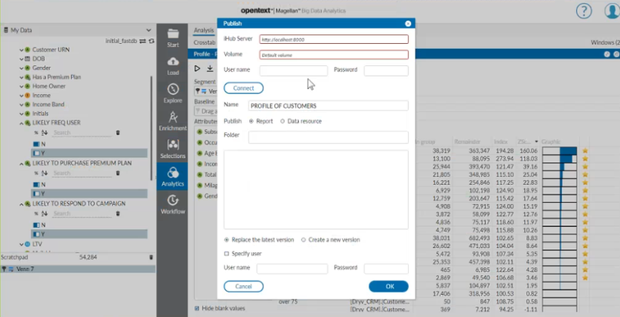

All we have to do is push it out of the data discovery tool, and realize this information and back through the eyes of our field marketing team. Now, the field marketers can simply leverage that AI as drag and drop.

***[Switch browser’s tab back to the Dashboard, and insert from Gadget Gallery]***

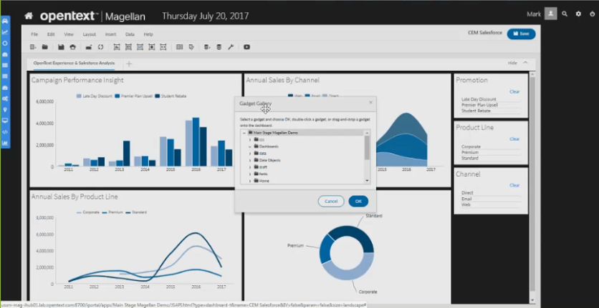

Let’s drop in an entire Dashboard.

***[Click on icon (Dashboard From Gallery). Select Apps > Main Stage Magellan Demo > Dashboards > Customer Profile ]***

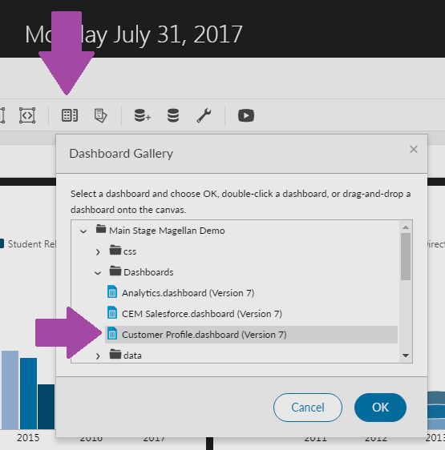

Here we see our customer profile, but it’s rather simply for our field marketers. They are absolved of having to understand any of the data science underneath. All they have to do is start to look up and find those customers that meet the criteria. We have built that micro-segment easily, leveraging the AI.

*<From script: we’ve realized the benefit of Magellan for targeted marketing, where AI is harnessed to select the customers most statistically likely to respond to our campaigns.>*

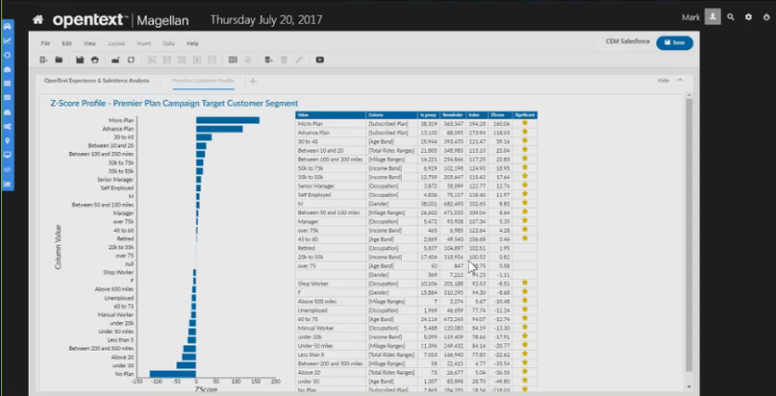

So **INFORMATION + ALGORITHM = INSIGHT**.

So that’s the theme here.

***[Click on Home of the Dryv app]***

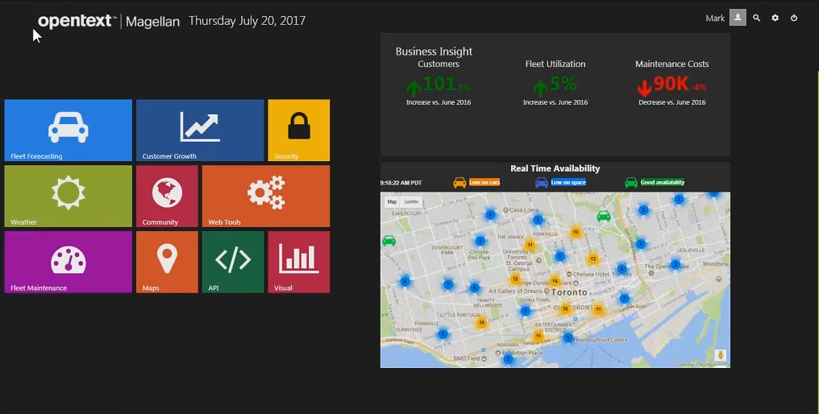

In another scenario, now with our successful campaigns, comes increased demand, which impacts Fleet management who must meet that demand.

Now, I’ll assume the role of the Fleet manager at Driyv.

***[Click on Fleet Management icon – upper left]***



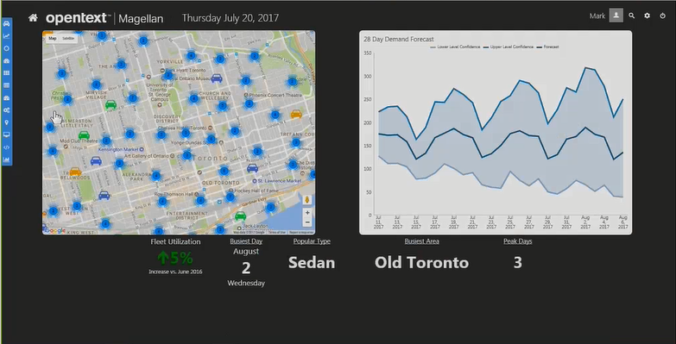

In this case, Magellan is helping us meet and manage demand and inventory by predicting future usage at each pickup location in the cities we service. So by running historic data from our electronic invoicing system through an algorithm called **Holt Winters**, or **Triple Exponential Smoothing**, we get insight in the form of a dashboard that shows each station, alongside a daily prediction of future demand.

***[Click on any of the cluster icons on the map to update the pop-up and the right chart gadget]  
 [Hover over chart so that the tool tips pop up]***

Each station that we click, we can actually determine the demand for that individual, or the demand in aggregate. This is really great. I can see exactly where the cars are needed when, and can distribute my inventory intelligently. This avoids costly reshuffling of inventory or worse of all, having a customer show up and having no car. That’s not going to make them very happy. So we can make more confident decisions to have satisfied customers.

In this case, let’s set up an additional scenario. And we’ll need additional information. We are already factoring in seasonality to our current prediction via history, but we know short term weather changes, like an unexpected temperature drop could dramatically impact our forecast accuracy. I would like to be as accurate as possible in distributing my inventory. So let’s turn to our data scientist to make an adjustment to our algorithm and factor in weather forecast data.

This is now where we transition and peek through the eyes of our data scientist who uses a Machine Learning Designer, called the Magellan Notebook.

***[OPEN Magellan Notebook via Click-Thru Tour]  
@ http://td-magellan.eastus.cloudapp.azure.com/DryvDemo/index.html#/screens***

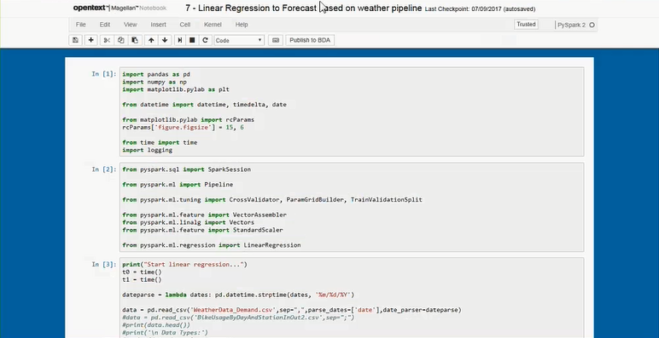

A “note” is a favorite environment for data scientists. It allows them to code algorithms in their favorite languages like Python, Scala, R, and many others. Most importantly, they can leverage the Machine Learning Library, or “MLlib” in Apache Spark to write AI-based models and processing routines.

***[MOVE mouse over Section 2 to point out…]***

So here is a“note” that has been created. We are not going to dissect this in-depth, but you can see we are pulling in the PySpark machine learning library (“pyspark.ml”) and we are importing a **linear regression** algorithm. This is another algorithm we are going to add to this routine.

***[SCROLL PAGE to Section 3 to point out… (CSV line)]***

And here we are pulling in NOAA weather data.

***[SCROLL TO BOTTOM and BACK UP to show the Scatter Plot and other charts]***

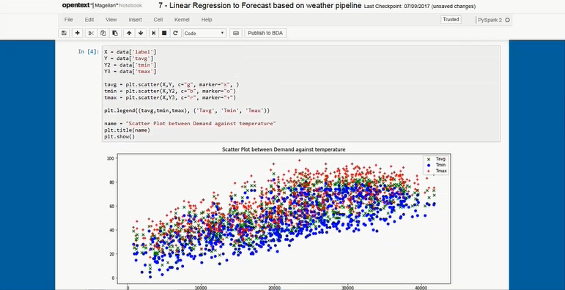

In this case, we see how the data scientist evaluated the model against the data by seeing a comparison between demand and temperature, or demand versus precipitation, or demand by day, and how accurate it could be.

***[SLOWLY SCROLL TO BOTTOM]***

And when the data scientist is confident that this model is accurate, and is trained, and ready for production, then this model is saved. It is saved back into the Spark ecosystem.

We want to be clear that we are not saving data. We are saving a model. This is important. Now the users can use their own data with this model.

Now with the AI coding done, I can share the model with knowledge workers and operational users across the organization.

All I do is publish the model, and then it is available in the Data Discovery feature of Magellan, just as we saw in the first scenario.

***[CLICK ON PUBLISH to BDA button in toolbar]***

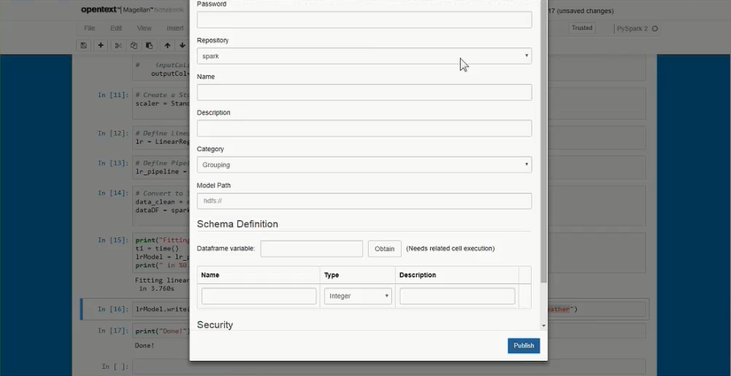

***[CHANGE tab back to BDA]  
[CHANGE BDA repository from initial_fastdb to spark]***

We are now back into the Data Discovery tool.

***[EXPAND My Data > default to reveal all tables]***

And when I click on the MLLib tab, I can see just published Forecast with Weather.

***[CLICK ON MLLib]***

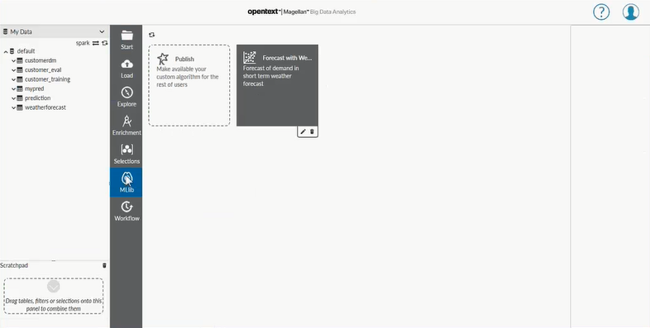

That’s the model that the data scientist had in code. But notice here…

***[CLICK ON Forecast with Weather tile]***

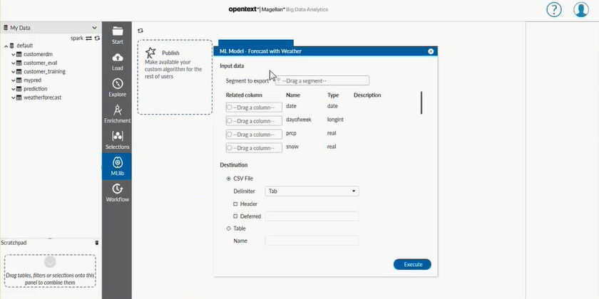

For the non-data scientist, it’s a simple drag and drop affair. Drag and drop AI.

I’m going to drag in my own weather data here.

***[SELECT AND DRAG ‘weatherforecast’ table from under My Data to ‘Segment to Export’]***

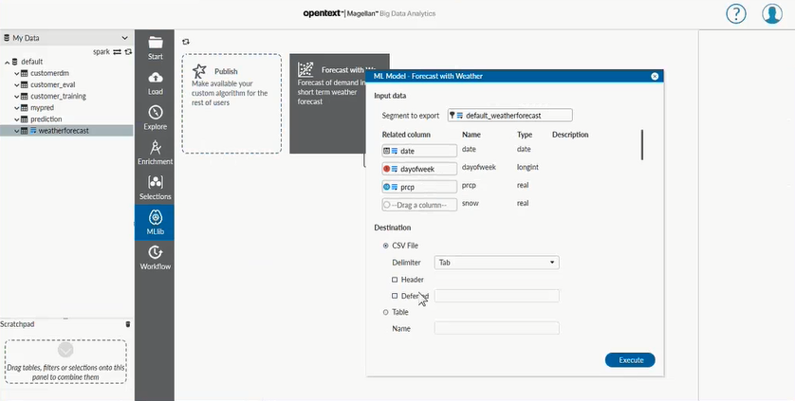

We can simply enter the name of the table we want to output, and we’ll Execute it.

***[TYPE ‘MyPrediction’ in the Name field under Destination > Table]  
[CLICK ON ‘Execute’ button’]***

It’s now taking my data and coming up with its prediction. And it happens really fast, thanks to Spark.

***[SELECT ‘MyPrediction’ table under My Data]  
 [OPEN/EXPAND if you want]  
 [DRAG AND DROP to Explore tab] [Right click to Explore if you want]***

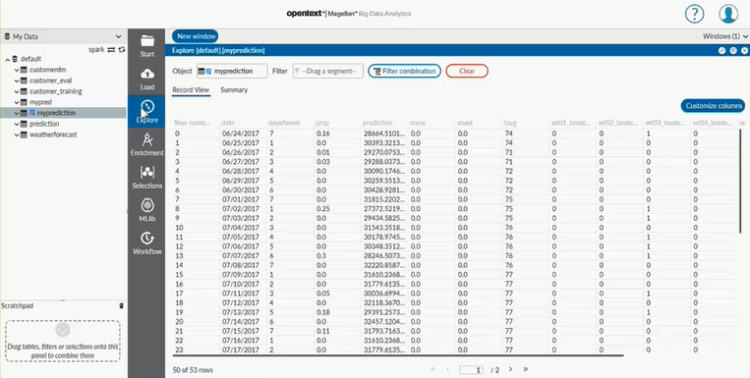

Spark is the platform that allows us to crunch massive amount of data. Here’s our data, but more importantly, there’s that prediction.

***[MOVE MOUSE to the ‘prediction’ column of table]***

The prediction can enrich our understanding of the future usage and utilization of our inventory.

*< FROM SCRIPT: Now with the AI coding done, I can share the model with knowledge workers and operational users across the organization.*

*All I do is publish the model, then its available in the Data Discovery feature of Magellan, just as we saw in the first scenario.*

*With our data processed through the updated algorithms, I can share the results with all my users in visual dashboards, lets go back to the fleet managers dashboard and see it adjusted for weather.>*

***[CHANGE BACK to iHub app tab]***

As we come back and refresh our dashboard…

***[CLICK on the GEAR icon (of app’s left hand menu) to show the refreshed dashboard with updated chart]***

We see now some adjusted prediction.

***[MOVE MOUSE and HOVER over middle dark blue line to show tool tips of OLD prediction]***

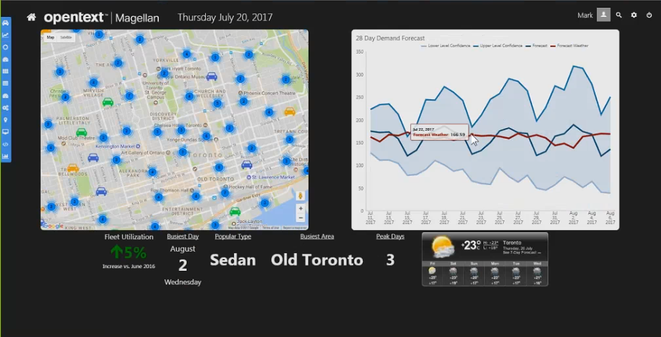

And in some cases, we see a dramatic difference. If we follow the original forecast, you might have a short-fall for particular days. The AI from our data scientist gives us a more immediate accuracy that we bring to the table.

So this information helps us minimize costly inventory shuffling and maintain a high customer satisfaction rating. It saves the organization money, and maximizes customer loyalty. That’s really the value of AI for business!

*<FROM SCRIPT: The chart shows the original prediction, right alongside the updated prediction, and thanks to Magellans AI capability we can see dramatic improvements in our prediction accuracy, on some days as much as 15% or more! This information helps minimize costly inventory shuffling and maintain a high customer satisfaction rating, saving the organization money and maximizing customer loyalty, that’s the value of AI for business!>*

***[Click on Home of the Dryv app]***

The final scenario… has to do with the success of the previous two scenarios. The campaigns were successful. We have increased utilization of the cars. Our Fleet Operations team needs to make sure the fleet operates at peak efficiency.

***[Click on the Fleet Maintenance icon to bring up this ‘dashboard’ report]***



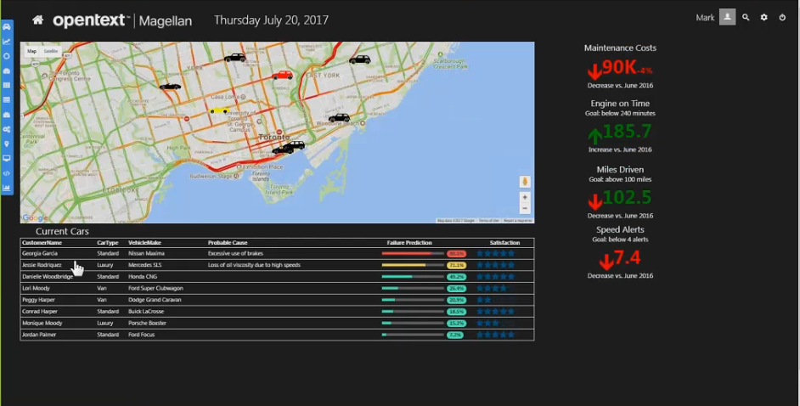

For this, we use Magellan to proactively maintain our fleet by: predicting maintenance and repair issues BEFORE they occur, reducing costly emergency fixes and breakdowns, and better ensure availability and utilization. The whole theme is making sure we service our customers better regardless of how we are applying Magellan.

In this case, the data comes from IoT devices in each car that stream on-board diagnostics information via the Covisint IoT platform. We are getting streams data such as engine temperature, tire pressure, fluid levels, and the like.

Magellan captures the data and runs it through a machine learning algorithm called **Random Forest**. It gives us a cars potential to suffer a maintenance issue based on real-time information, not a maintenance schedule. And then finally the insights are delivered to fleet operations as easy to understand dashboards, which depicts cars in danger of maintenance issues in real time on a map.

When a vehicle is predicted to have an issue, the icon on the map turns red.

***[Click on the car that is RED – right in the center of map]***

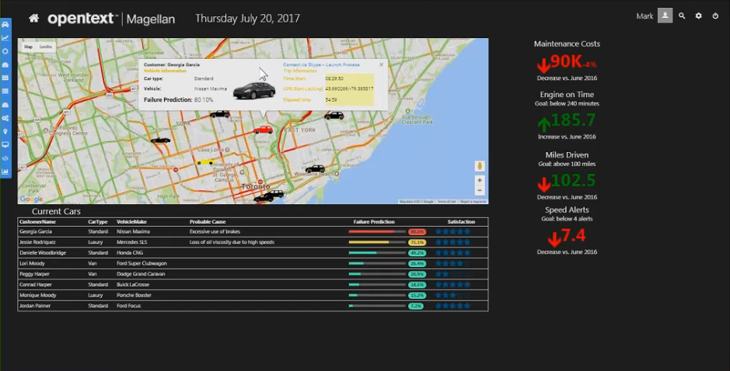

Clicking the icon shows us the current information about the vehicle and driver, but most importantly it gives me the prediction, allowing me to perform repairs BEFORE the car breaks down and needs to be taken out of service altogether.

Huge value. Very subtle effect, but huge value to the organization.

So again **INFORMATION + ALGORITHM = INSIGHT**. That helps drive business better.

In summary, Magellan helps our organization by:

* Predicting customer behavior, so we can market to them better
* Predicting demand and utilization of our services, so we can serve those customers better
* Predicting and responding to maintenance issues, making us more efficient and competitive

Magellan gives us the advantage to disrupt the car sharing market and realize business success.

***That’s the power of Magellan and AI for business.***